Trigonometry Project
DUE:
Objective: To create and solve your own real-life trigonometry problem. You may create parts/all of your project digitally, but it must be turned in as a poster. (i.e organized hard copy). All projects must be ready to turn in when the bell rings on the due date.
Materials:
- Clinometer | - Computer/Printer | - Paper 8x10 | - Protractor
- Tape measure | - Camera/Smart Phone | - 4 large objects

Content:
4 Angles of Elevation and Depression Problems:
- 1 of the problems must be Angle of Elevation and 1 must be Depression
- 1 involving Sine or Cosine (done twice by 2 different people and different measurements)
- 1 involving Tangent (done twice by 2 different people and different measurements)
- Real life picture must be taken/used
- Information on picture must be easy to see/read

Grade Breakdown:
4 Angles of Elv. and Dep. 100 points
Self Reflection 20 points *** Group members will receive daily participation
grade based on assigned task completion.**
Total 120 points

Group Members

_________________________________________ ________________________________________

________________________________________ ________________________________________

Project Criteria:
Angle of Elevation and Depression Problem
- Creative word problem that explains the scenario in the picture
- You must have 1 angle of elevation problems and 1 angle of depression problems.
- Set up and include a question that requires the solver to use indicated trig ratio or form a missing angle
  - Don’t say …. “use sine to solve this problem”
- All important information (measurement and variable) overlay on the picture
- Generic triangle with just the important information
- All work necessary to solve the problem
- Answer to problem
- Each group member is responsible for one picture in which they are in.

Check List
Sine/Cosine(1) | Sine/Cosine(2) | Tangent | Tangent
- Word Problem  - Requires solver to use sine/cosine  - Overlay on picture  - Generic Triangle  - All work  - Answer | - Word Problem  - Requires solver to use sine/cosine  - Overlay on picture  - Generic Triangle  - All work  - Answer | - Word Problem  - Requires solver to use tangent  - Overlay on picture  - Generic Triangle  - All work  - Answer | - Word Problem  - Requires solver to use tangent  - Overlay on picture  - Generic Triangle  - All work  - Answer

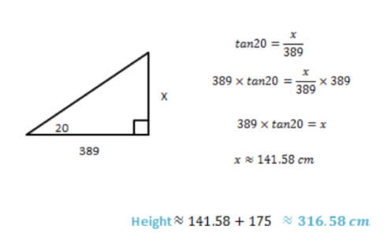
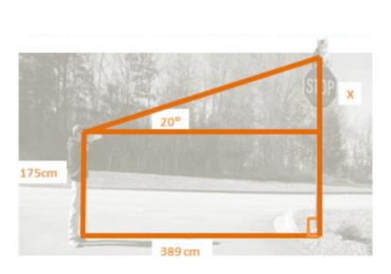
Example
Lucas is trying to save his neighbors mischievous kitten who has climbed to the top of a nearby stop sign. The angle of elevation from Lucas to the cat is 20º and he is standing 389cm away from the stop sign. How high must Lucas climb to rescue the cat? The distance form Lucas ‘eye to the ground is 175cm.

Angle of Elevation and Depression Rubric
 | Excellent | Proficient | Marginal | Emerging
Completion | All requirements have been included  (10 pts.) | Over ½ but not all requirement have been included  (8 pts.) | Approximately ½ of all requirements have been included  (5 pts.) | Less than ½ of all requirements from checklist have been included  (3 pts.)
Presentation | All problems are completed legible, neat, and organized  (14 pts.) | Most problems are legible, neat and organized  (11 pts.) | Some problems are legible, neat and organized  (7 pts.) | Problems are not legible, neat, and/or organized  (3pts.)
Contains 2 types of problems | Project contains one good problem of each type  (16 pts.) | Project contains one good problem and one that is not thought out  (12 pts.) | Problems show thought, but are lacking some information  (8 pts.) | Project contains only one problem not thought out  (4 pts.)
Realistic problems | Problems are realist and give realistic distances as well as degrees  (10pts.) | Lengths are realistic but angles are not  (8pts.) | Lengths or angles are almost realistic  (5pts.) | Not are realistic  (2pts.)
Picture | All real-life, overlay, and generic pictures are included and all information accurate  (20 pts.) | All real-life, overlay, and generic pictures are included with no more than 1-2 errors  (15pts.) | All real-life, overlay, and generic pictures are included with no more than 3-4 errors  (10 pts.) | All real-life, overlay, and generic pictures are included with no more than 5 errors  (5 pts.)
Equation & Calculations | All calculations are accurate and  no errors were made when setting up equations.  (30 pts.) | No more than 1-2 errors in calculations and setting up equation  (25 pts.) | No more than 3-4 errors in calculations and setting up equation  (15pts.) | 5 or more errors in calculations and setting up equation  (5 pts.)
Angle of Elevation and Depression Grade: $\frac{}{100}$

